**Name: Dharmavarapu Sravya Sri**

**Project name: Sushra**

**Introduction**

We will learn about the specific concepts of hotels in this project, as well as how their associated data tables connect to the main table. The full schema for this project consists of six tables: bookings, users, locations, cities, nations, and reviews.

Let's look at a case study that describes my workflow and results.

**Dataset**

I started by looking at the information. There are 6 tables in the Sushra Hotels database. The various tables and a short summary of each are listed below.

users— contains user data including the user’s id, first name, and last name.

bookings— contains booking data such as booking id, start date, end date, number of stays, etc.

places — contains the data related to Sushra hotel branches’ locations.

cities— contains the data related to cities where Sushra hotel branches are located.

countries — contains the data related to countries where Sushra hotel branches are located.

reviews — contains the reviews of customers on their hotel stays at Sushra*.*

**Objective & Goals**

**The following queries will be addressed in this project:**

1. create a new column that provides the information of the welcome gift: if the booking is from a female, then provide a plum gift hamper else provide a deodorant.
2. create a common table expression(CTE) with all the bookings and join this new table with places showing the branches where bookings are created.
3. Create a view and add a new column to the result called priority to group results into the following priority groups top-rated, medium-rated, and low-rated the range for each group is provided in the table below high>= 8 *, medium in (5,7,6) and low<5.
4. Create a query to know the users who have bookings on 21-02-13 and the total amount that Sushra got for those bookings?
5. Create a query to show the top-rated places of Sushra hotels based on customer ratings?
6. Create a query to display all the booking IDs who stayed in the Philippines?
7. Create a query to show the customers that they had a stay more than twice in Sushra and need to get their details just in case want to reward them.
8. Create a query to display the average income for bookings from February 13, 2022, to January 14, 2023.
9. Create a query to display all the user details who stayed in Russia.
10. create a query that should display the booking details having more than two days stay at '243 Moulton Avenue.

I first made an effort to comprehend the ERM (Entity Relationship Model), also known as the Schema, of this database before beginning any studies. The schema is provided below:

[SUSHRA HOTEL SCHEMA](http://www.postgresqltutorial.com/postgresql-sample-database/)

My GitHub page has a copy of my code 🡪 [GitHub - dsravyasri-2509/SQL_Project](https://github.com/dsravyasri-2509/SQL_Project)

**Data Base and tables Creation Queries:**

**Data Insertion Queries**

**/*Data Insertion for the table USERS/\***

**/*Data Insertion for the table countries */**

**/*Data insertion for the table cities/\***

**/*Data insertion for the table Places/\***

**/*Data insertion for the table Bookings/\***

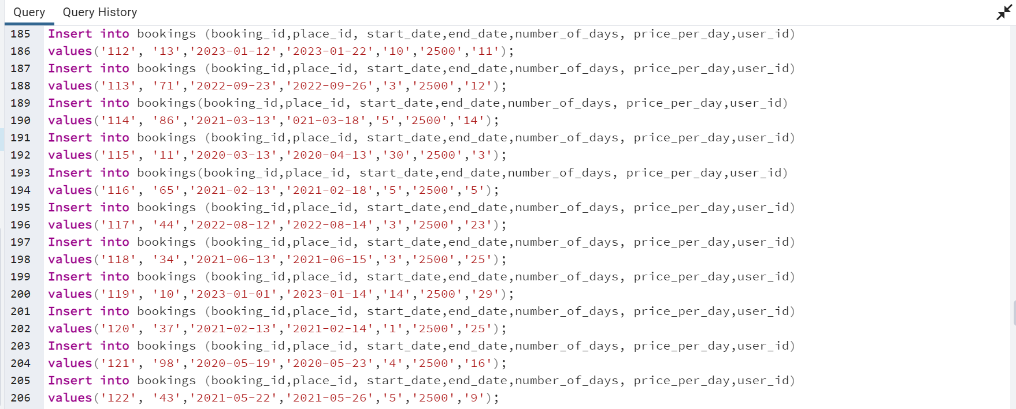

**/*Data insertion for the table Reviews/\***

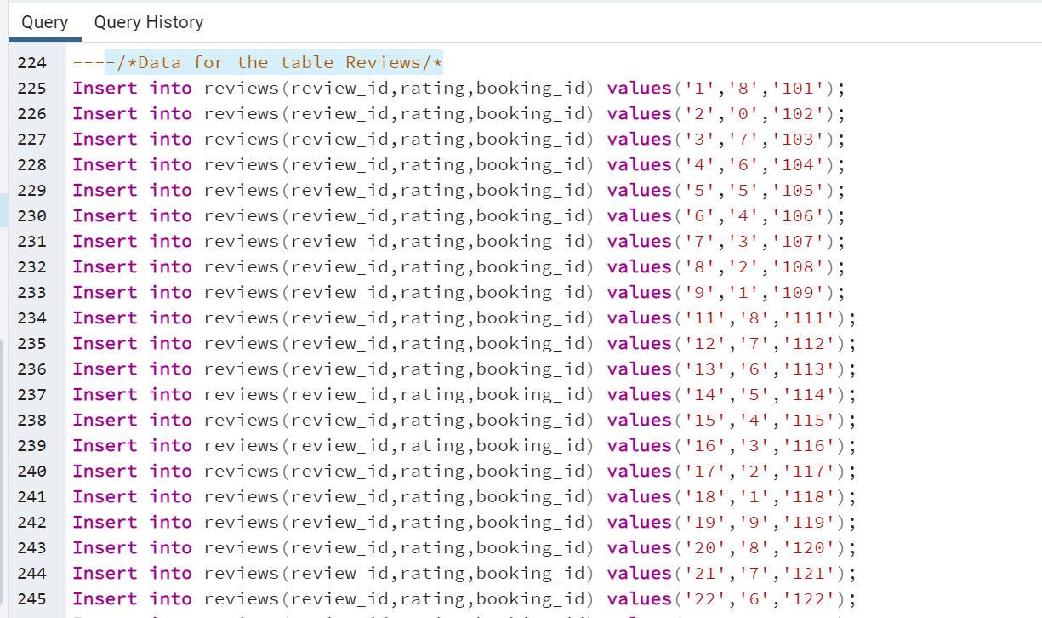

**Analysis:**

1. To answer the first question “**create a new column that provides the information of the welcome gift: if the booking is from a female, then provide a plum gift hamper else provide a deodorant”**, I first identified with tables I would need to Join, which are:

**Users>Bookings**

Below is the query I used to extract to answer the question:

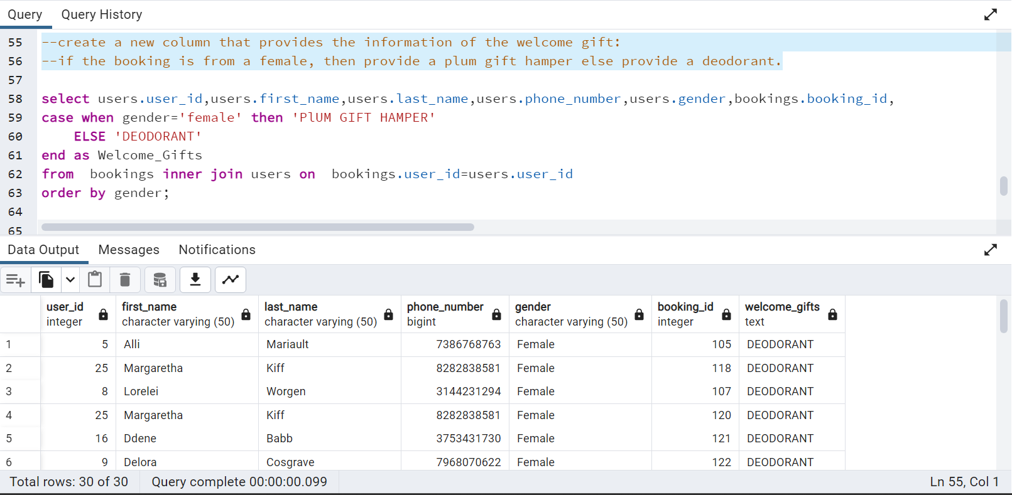

1. To answer this question “**create a common table expression (CTE) with all the bookings and join this new table with places showing the branches where bookings are created.”**  I need to join a few tables which are below.

**bookings>places**

Below is the query I used to extract to answer the question:

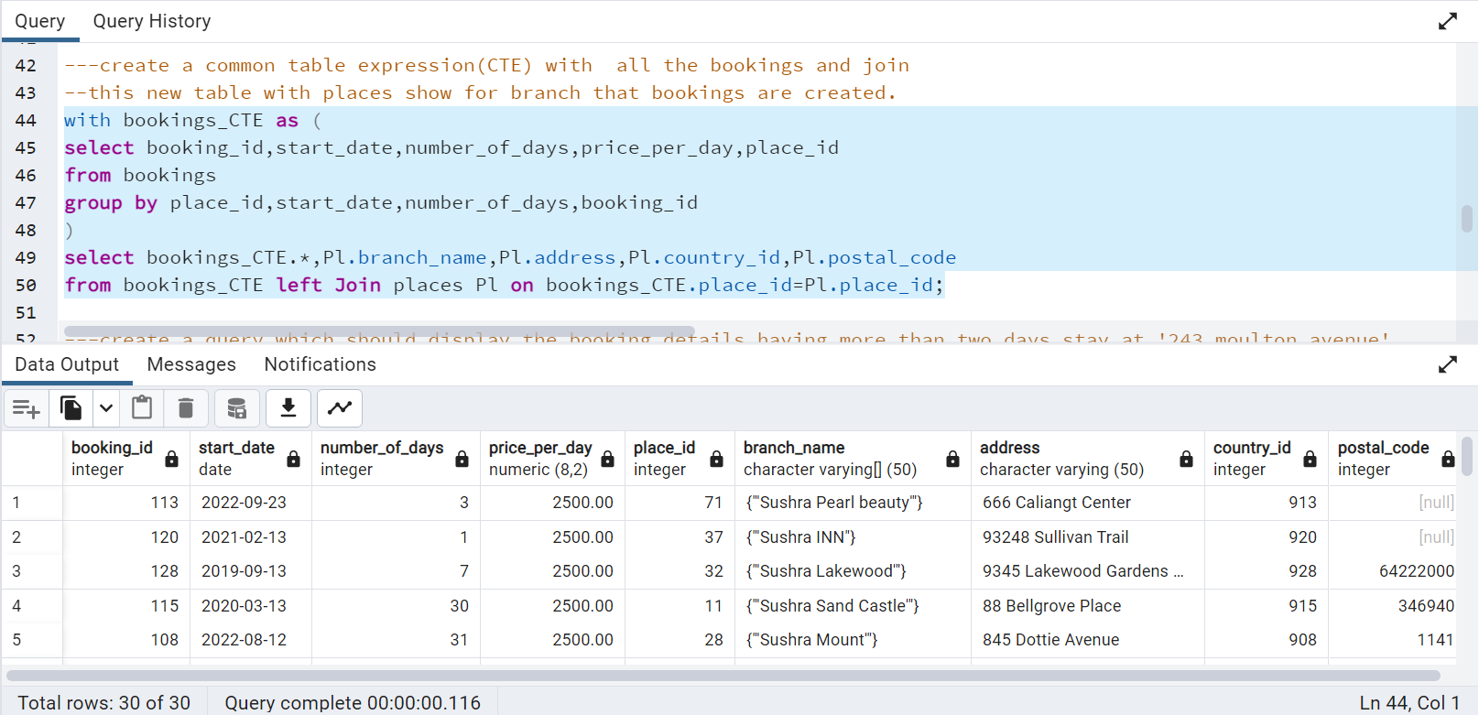

1. To answer this question “**Create a view and add a new column to the result called priority to group results into the following priority groups top-rated, medium-rated, and low-rated the range for each group is provided in the table below high>= 8 *, medium in (5,7,6) and low<5.”** first, I need to create a view by joining tables below

**bookings > places >countries**

Below are the queries I used to extract to answer the question:

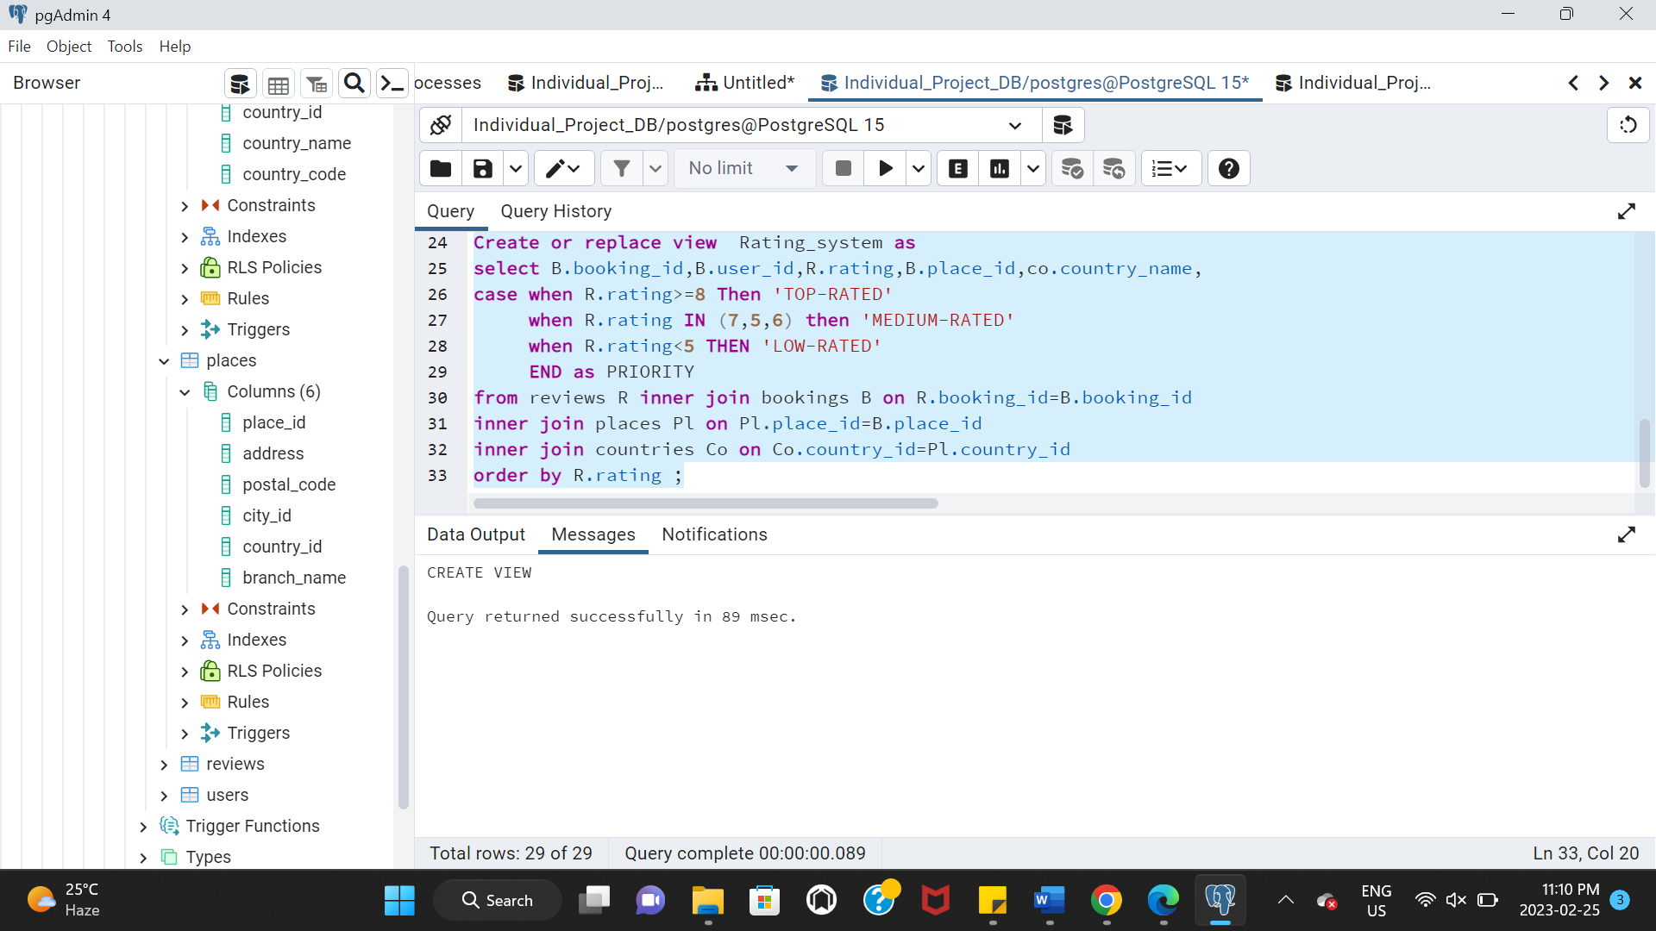

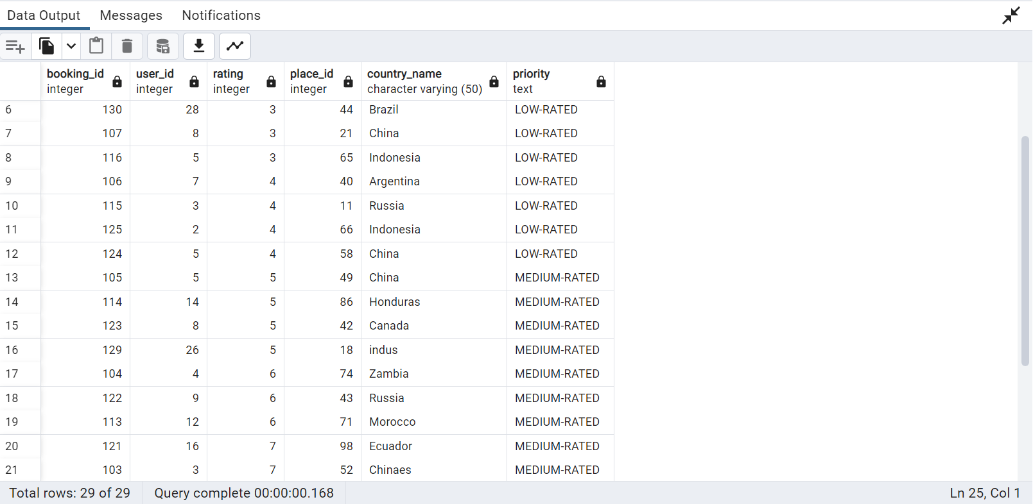

1. To answer this question “**Create a query to know the users who have bookings on 21-02-13 and the total amount that Sushra got for those bookings?”**  I need to get the booking ids from the Booking table and need to calculate the total amount by using the below formulae.

**Total_booking_amount=number_of_days*price_per_day**

Below is the query I used to extract to answer the question:

1. To answer this question **“Create a query to show the top-rated places of Sushra hotels based on customer ratings?”** I need to join four tables which are

**reviews>bookings>places>countries**

Below is the query I used to extract to answer the question:

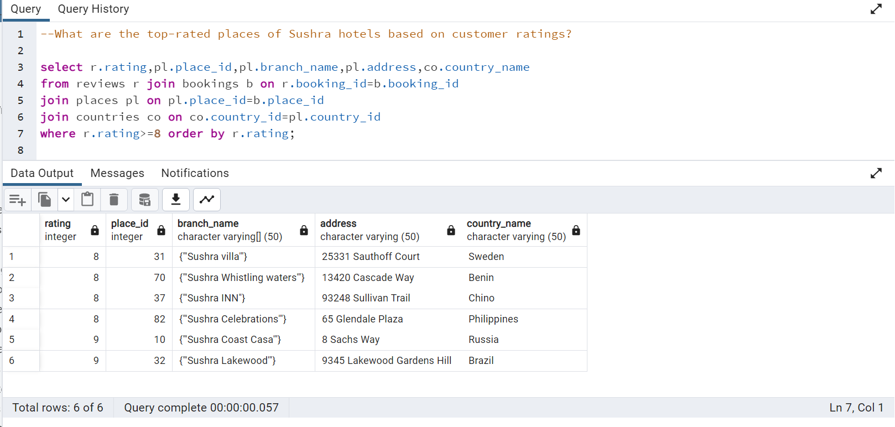

1. To answer this question “**Create a query to display all the booking IDs of those who stayed in the Philippines?”** I need to get bookings from the Philippines country by joining below two tables.

**bookings>countries**

Below is the query I used to extract to answer the question:

1. To answer this question **“Create a query to show the customers that they had a stay more than once in Sushra and need to get their details just in case want to reward them.”**

I need to get the user details of those who stayed more than two once in sushra hotels by joining the below tables.

**Users>bookings**

Below is the query I used to extract to answer the question:

1. To answer this question **“Create a query to display the average income for bookings from February 13, 2022, to January 14, 2023.”**  I have used a math calculation here in this query to get the average income of bookings in that period.

Below is the query I used to extract to answer the question:

1. To answer this question “**Create a query to display all the user details who stayed in Russia.”** I have taken booking details from Russian branches by using the below tables.

**bookings>places>countries**

Below is the query I used to extract to answer the question:

1. To answer this question **“create a query that should display the booking details having more than two days stay at '243 Moulton Avenue'**” I have taken the data by filtering the address and have also used the below tables to display the required data.

**Bookings>places**

Below is the query I used to extract to answer the question:

### **Conclusion**

In this project, we analyzed data from Sushra hotel’s insights and customer reviews. We got a few major conclusions:

1. The hotels have loved customers and their branches are present all over the world with wide exposure.
2. One interesting fact that I found while analyzing the data is the price of stay per day is the same all over the world from the year 2019 to till date.
3. In addition to that, in every other hotel stay will be based on the number of nights customers will stay but in Sushra, it is based on the number of days that will get counted as their stay.
4. Moreover, they are providing gift hampers according to the customer’s gender as welcome gifts.
5. Overall, I found these hotels are very customer friendly and affordable for every person.